'He's a great dude': Shaq apologizes to 'new friend' Jahmel Binion after he mocked the disabled man on Instagram
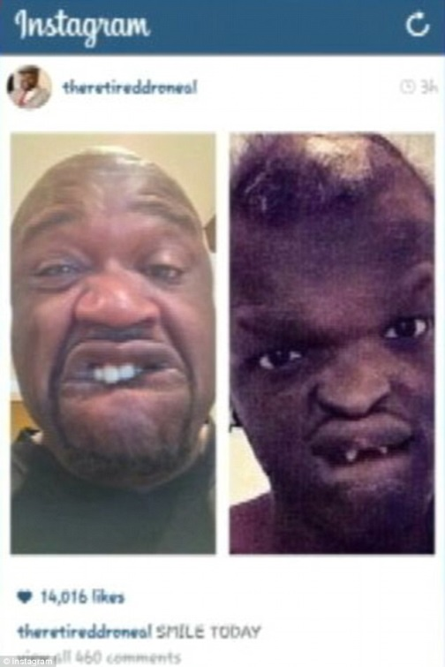
- Ex-NBA star Shaquille O'Neal announced the apology in a Twitter message Tuesday, after his post making fun of the Detroit man's rare disorder sparked outrage
- 'Made a new friend today when I called and apologized to Jahmel Binion. Great dude,' the tweet said
- Binion has ectodermal dysplasia, which affects his face, teeth and hair
- He told MLive.com that he was 'confused' when O'Neal posted a picture on Instagram showing him making a face imitating Binion
- The post was later taken down
- The National Foundation for Ectodermal Dysplasias wrote an open letter Monday to O'Neal saying 'bullying is never acceptable'

By ASSOCIATED PRESS and DAN BLOOM
PUBLISHED: 01:39 GMT, 1 May 2014 | UPDATED: 17:56 GMT, 1 May 2014
Ex-NBA star Shaquille O'Neal has apologized to a Detroit man with a rare disorder for making fun of his appearance in an online post.
Best known as Shaq, the former NBA player announced the apology in a Twitter message Tuesday.
'Made a new friend today when I called and apologized to Jahmel Binion. Great dude,' the tweet said, with the hashtags #alwayslearning and #MYBADCUZ.
O'Neal followed up Wednesday with a tweet that said: 'Had the opportunity to talk to Jahmel Binion yesterday and apologize about the post on IG!'
O'Neal spokesman Rishi Daulat told The Associated Press on Wednesday that O'Neal personally wrote the tweets. Daulat declined further comment.
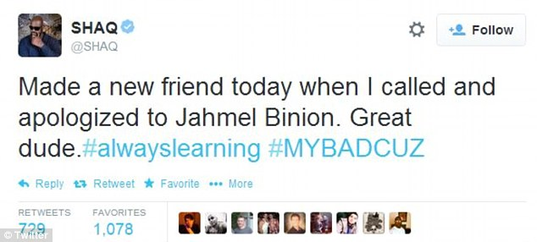

Tweet: Ex-NBA star Shaquille O'Neal has apologized on Twitter, pictured, to a Detroit man with a rare disorder for making fun of his appearance in an online post

Binion has ectodermal dysplasia, which affects his face, teeth and hair.
He told MLive.com that he was 'confused' when O'Neal posted a picture on Instagram showing him making a face imitating Binion.
'I was thinking "Man, he's supposed to be this role model, someone everyone is supposed to look up to. If Shaq does something like this,"' Binion said, everyone who follows him 'will think, "We should do this."'

The post was later taken down. AP left an email message for Binion on Wednesday afternoon seeking his reaction to O'Neal's call.
The National Foundation for Ectodermal Dysplasias wrote an open letter Monday to O'Neal saying 'bullying is never acceptable.'

The outrageous photo immediately prompted outrage immediately after it was posted on the photo-sharing website.
Jahmel Binion, whose ectodermal dysplasia hinders his ability to grow teeth and hair, was dumbfounded when thousands of internet users imitated and mocked a selfie he took.
They included Shaq, who has now apparently deleted the Instagram photo - which said 'SMILE TODAY' - and uploaded one comparing himself to the cartoon ogre Shrek.

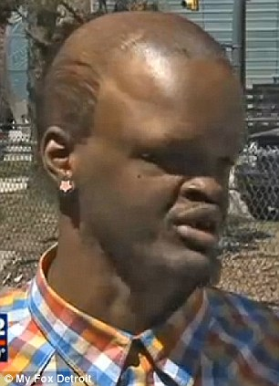
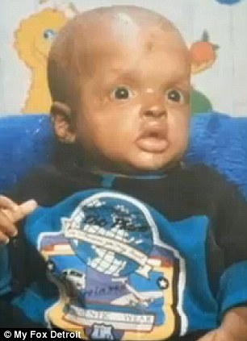
+5
+
Mocked: Jahmel Binion (left) had ectodermal dysplasia since he was a baby (right) and has begun an anti-bullying campaign. He said he was disappointed by the NBA star because he saw him as a role model

+5

But the move was too late to stop a storm of comments from many of Shaq's 500,000 followers on Instagram and 8.3million on Twitter.
The controversy comes after criticism of another top figure in basketball, billionaire LA Clippers owner Donald Sterling, who is embroiled in a racial discrimination row.

Many Instagram and Twitter users today demanded Shaq apologized for the photo.
And instead of hiding away, 23-year-old Mr Binion has used the publicity to start a campaign to raise awareness of his condition.
Called Hug Don't Judge, a Facebook page for his campaign has gained more than 3,500 fans and been flooded with photos by parents whose children have the same disorder.
The description reads: 'This page is to support my anti-bulling and cyber bullying organization.

'Please be respectful, be positive and share this with the world. Time to make a difference.'
Mr Binion, 23, told My Fox Detroit: 'I've been getting teased since I was yea tall - people laugh at me, stare at me.

'I was kinda hurt because I look up to him and I watch Shaq play basketball so I was like, why is he making fun of me when he's supposed to be this role model?'
'I can't let it get to me, then I get hurt and depressed, so I keep my mind positive.'
The storm prompted the National Foundation for Ectodermal Dysplasias to write an open letter to the NBA legend.

Executive director Mary Fete said there were more than 180 forms of the condition and many left sufferers with missing teeth and unable to sweat.
She wrote: 'You might want to consider making something positive come from this. Consider giving Jahmel Binion the gift of a smile, one that others would not make fun of.
'Give him a smile that would give him confidence and pride.'
So far Shaq has not responded publicly to the row.
Some users rushed to the 7ft 1in four-time NBA champion's support, saying people were too easily offended and Shaq may not have known Mr Binion had a disibility.

The controversy comes after another top figure in the NBA, billionaire LA Clippers owner Donald Sterling, made headlines when a tape of an alleged racist rant was leaked to TMZ.
He is allegedly heard telling his girlfriend she can 'sleep with black people' but not bring them to matches.

'You can bring them in, you can do whatever you want,' the voice on the tape says. 'The little I ask you is not to promote it on that... and not to bring them to my games.
'It bothers me a lot that you want to broadcast that you’re associating with black people. Do you have to?

'I’m just saying, in your lousy f******* Instagrams, you don’t have to have yourself with, walking with black people.

'Don't put him (Magic Johnson) on an Instagram for the world to have to see so they have to call me. And don't bring him to my games.'

In 2009 Sterling agreed to a $2.76 million settlement over claims he discriminated against African American and Latinos tenants at apartments he owned. He did not admit any liability.

