Name: Date: Blk:
Science 9
1.3 Study Guide
1. Four scientists contributed to the atomic model. What did each scientist contribute?
Thompson:
Rutherford:
Dalton:
Bohr:

2. State the Atomic Theory:

3. What three things make up an atom?

4. Label the diagram (electron, positive, neutron) AND state the charge (positive, negative, neutral).

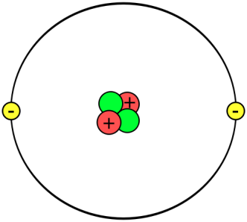

5. How much do the following weigh?
Protons Electrons Neutrons

