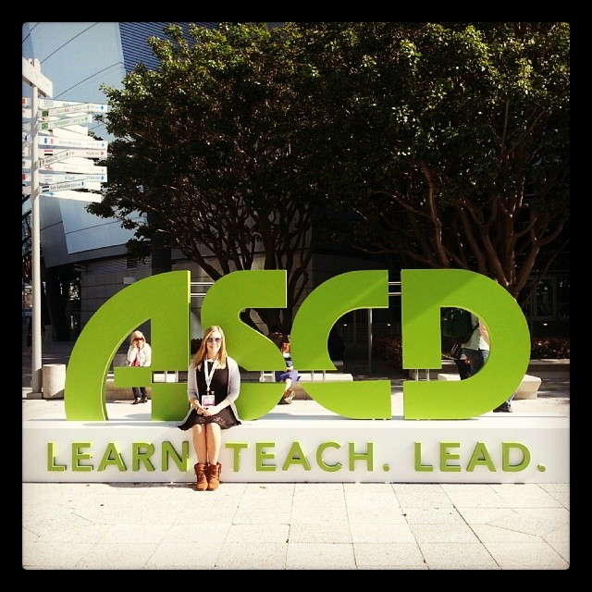
A Palindrome for
Real Teachers

There is no hope
For the education system
We cannot say that
We are doing the right thing.
Inquiry, collaboration, project-based learning
Why?
We ultimately fail.
It cannot be said that
Learning is life-long.
We believe
Memorization and the power of test scores
Let us stay away from
Cross-curricular mash up and play
And embrace
Rote learning and teacher-centered education
Because teachers can change
Nothing.
It is not acceptable to do
New things, change lesson plans and integrate technology.
Let’s just try
Try the same things and expect different results.
It’s deranged to
Not give up now.
To re-examine, to reignite, and to rethink –
To find purpose and passion
I’ll tell you
What’s the point?
It isn’t easy
What we do as teachers –
Keeping the status quo
Works
What
Needs fixing.
Not learning or being engaged
Dismissing creativity, forgetting fun -
In thinking this
I will let my students know that
School is wasted on the young.
Some say
Education is important but
Real teachers see things differently.

Now read it backwards – line by line

