Passion Project

Grade 9 English

Name:
Date:

Due Dates
Using the calendars provided, decide when you will be submitting the various pieces of writing for draft editing.

All Six Pieces are Due No Later than

Express and Reflect
Draft 1:
Draft 2:
Inform and Explain
Draft 1:
Draft 2:
Evaluate and Judge
Draft 1:
Draft 2:
Inquire and Explore
Draft 1:
Draft 2:
Analyze and Interpret
Draft 1:
Draft 2:
Take a Stand/Propose a Solution
Draft 1:
Draft 2:

The Project
“The reason students can’t write, is because they cannot think.”
- Dr. Tony Wagner

This portfolio of writing is designed to combine your passion with effective writing skills and strategies.
Step 1: Choose a topic – any topic. What are you passionate about? Hockey? Volleyball? Dancing? Cooking? The Toronto Maple Leafs? The sky is the limit.
Not all writing is the same. Using this topic, you will write six different pieces – all a MINIMUM of paragraphs each. Each piece of writing will have a different focus and purpose. You will dabble in the six most common types of writing.

Topic:

Step 2: Using the model text, complete the graphic organizer for your topic.
*Graphic Organizer = 10 marks

Step 3: Plan and Research
For each purpose, take a moment before you start writing and plan your composition. For the more complicated types of writing, you will need to do some research in order to substantiate your claims and ideas.

Step 4: Write.
When you are ready, begin writing. You should plan to submit two drafts/piece for feedback before you submit your final draft.

Formatting and Submission
Graphic Organizer
- Marked for completion – include in final portfolio
Drafts
- Drafts should be submitted for feedback at least once before final submission.
- MLA format (would be nice)
- Double spaced
- Typed
- Electronic is ok (Google Classroom Folders will be created)
  - I will NOT accept drafts unless they go through the Google Classroom
Final
- Final copies of writing will be handed in on
- MLA format
- Typed (12 pt. font; Times New Roman, Cambria, Calibri, or Georgia)
- Double Spaced
Portfolio
- Presentation is everything!
- Doutang/Folder
  - Title Page
  - Graphic Organizer
  - Rough Draft(s)
  - Good Copies
  - Works Cited
  - Self-Assessments

**You will also hand in your Visual Journal with your passion project.

Evaluation/Grading

Graphic Organizer /10 marks
Express and Reflect* /10 marks
Inform and Explain* /10 marks
Evaluate and Judge* /15 marks
Inquire and Explore* /15 marks
Analyze and Judge* /20 marks
Take a Stand/Propose a Solution* /20 marks
Work Cited /10 marks
Visual Journal* /20 marks

*Refer to Rubrics for specific grading rules.

Total /130 marks

MLA - Format

Your Name
Note: MLA formatting is very boring, but it looks clean cut, and professional. No fancy fonts. All 12 Point font, and no bold, italics, or underline anywhere – unless it is WITHIN your essay.
Your Teacher’s Name
Course
Date (dd mm yyyy)

Title
Essay/Response.
- Double Spaced
- 12 point font
- Left Alignment (except for the indented paragraph)
MLA Format Example:
Jones 1
Billy Jones
Ms. Citton
EN 9
22 October 2013

Truth or Dare

It was a hot summer night. The boys and I were in our tree-fort discussing the important things: hockey, girls, girls, pizza, girls, and girls. Needless to say, girls were on our minds. Jeremy, Simon, Luis, and I were girl crazy.

MLA format will apply to anything you write in your humanities subjects: English, Social Studies, and Christian Education. Blow your teacher’s minds by following this format!

How To’s – in Microsoft Word
Double Space:
- Highlight what you want to be double spaced (aka your essay/response)
- Click “Paragraph”
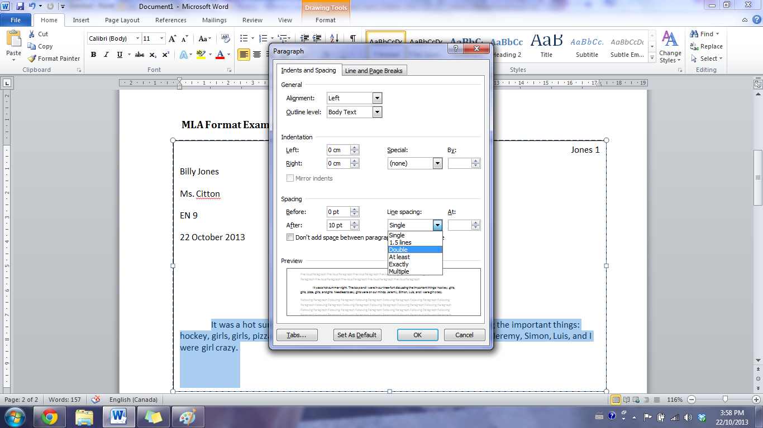
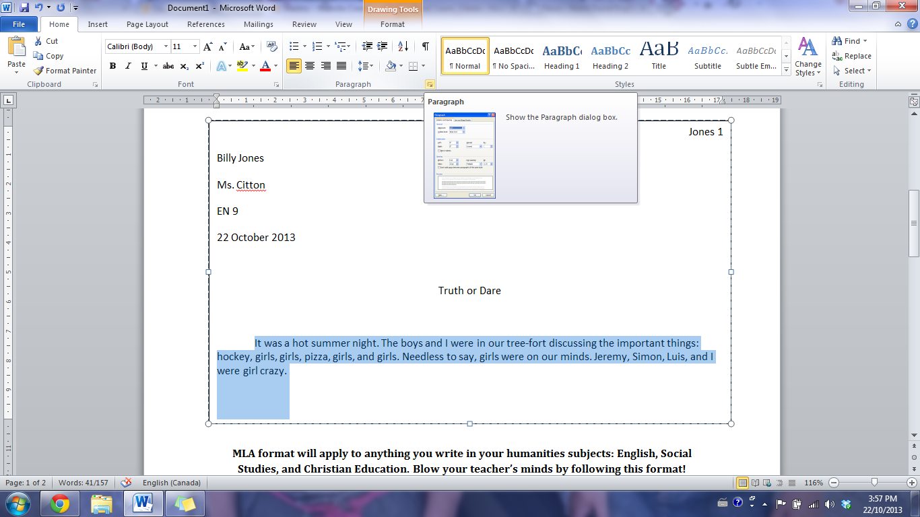
- Change Line Spacing to DOUBLE.
Page Numbers and Last Names
- Insert
  - Page Number
    - Top of Page
      - Right hand side
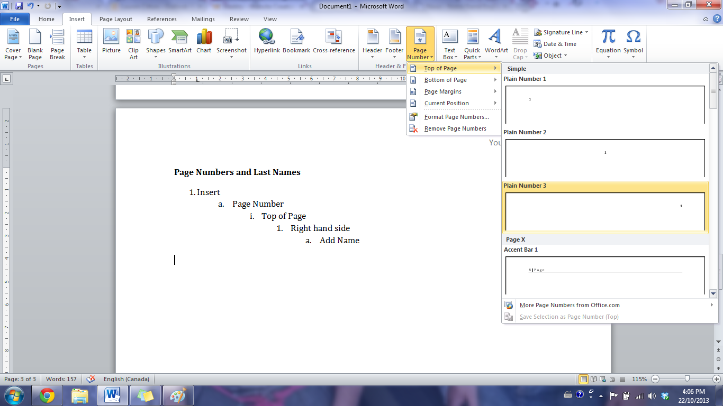
        - Add Name

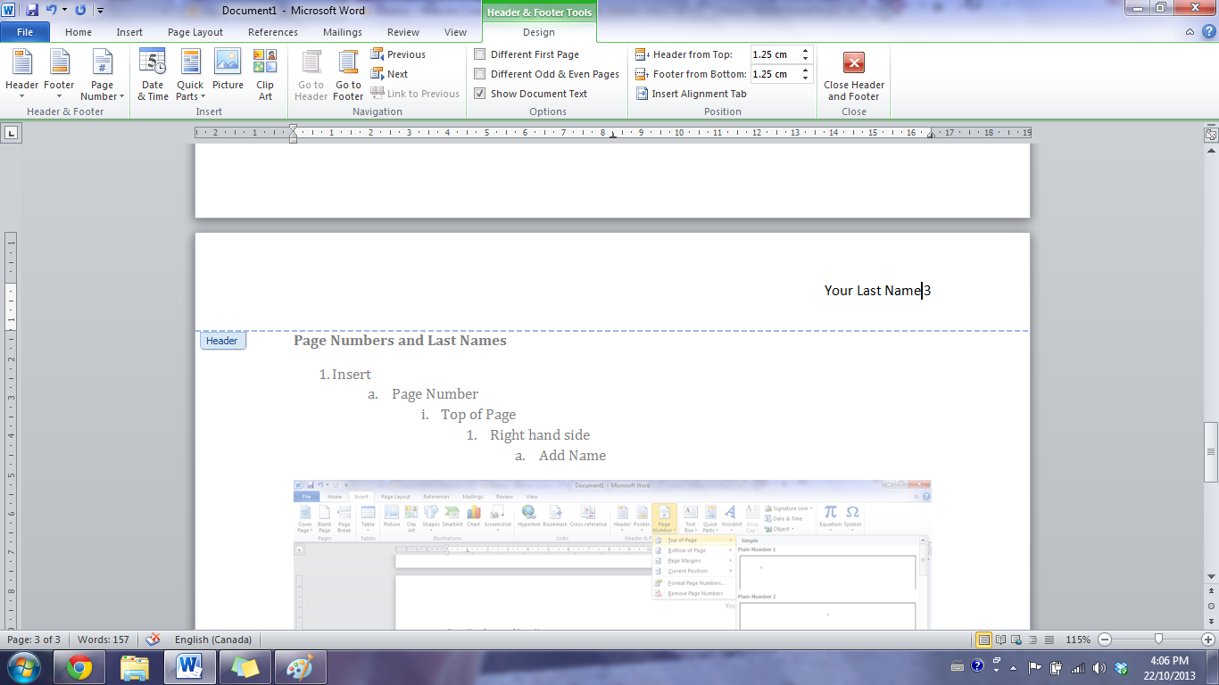

MLA – Works Cited
Use easybib.com to correctly format your works cited page. We will go over this in class, but if you want to get a head start, take a look.

Google Classroom
In order to submit assignments online, you will need to use your @myndrs.com accounts. If you cannot remember the password to your @myndrs.com accounts, you will need to see Mr. Vogel to get your passwords reset.
To access our Google Classroom, log in to your @myndrs.com account and Google Search:
“Google Classroom”
It will likely be the first link. Click “Go to Classroom” – and enter the Classroom ID:
sz5rwm

If you are having trouble, let me know and I can invite you with an evite.

Final Check List

- Visual Journal – up to date and complete
- Portfolio:
  - Duotang/Folder with your NAME on the OUTSIDE
  - Title Page
  - Graphic
  - Rough Drafts of work
  - Final Copies of Work
  - Works Cited
  - Self-Assessments (1 per piece)
- Writing:
  - Proper MLA format used
  - Follows criteria
  - Well-written and thoughtful
  - Six separate documents
- Other:

1 Topic = 18 Topics
Graphic Organizer
Example
Purpose | Possible Writing Topics
Express and Reflect  - Feel/Lessons | - How I came to love volleyball  - What a loss taught me  - How it impacts my life
Inform and Explain  - Tell something about your topic that the reader might not know | - Explain the game  - How I learned volleyball  - What it has taught me  - Explain the reason I love volleyball
Evaluate and Judge  - “worth”  - Good/Bad | - Best moment I had in volleyball  - Best hit  - Worst game
Inquire and Explore  - Wrestle with a question | - Who came up with the sport of volleyball?  - Why is volleyball less popular than basketball?  - What is the history of volleyball?
Analyze and Interpret  - “WHY” | - Why did we lose some of our games?  - Why we won our first league game?  - Why does volleyball require jumping?
Take a Stand/Propose a Solution | - Volleyball should be popular around the world.  - The referees calling the game have to be trained.  - How to get our team to work together.

One Topic:

VOLLEYBALL

1 Topic = 18 Topics
Graphic Organizer
Your Turn – 10 marks
Purpose | Possible Writing Topics
Express and Reflect

- Feel/Lessons

Inform and Explain

- Tell something about your topic that the reader might not know

Evaluate and Judge

- “worth”
- Good/Bad

Inquire and Explore

- Wrestle with a question

Analyze and Interpret

- “WHY”

Take a Stand/Propose a Solution

One Topic:

