Name:

**Does the Mask I Wear Represent Who I Am?**

Humanities 8: Personal and Cultural Identity

Over the past few weeks, we’ve been exploring the concept of Identity – both personal and cultural. As a culmination and celebration of this learning, we will be pulling together all of the artifacts we’ve created into a visually appealing and concrete expression of who we are.

**What We’ve Written:**

* Personal Character Sketch
* 3 Core Memory Stories
* Bio Poem
* Cultural Poem

**What We’ve Created:**

* Plaster, personal masks
* Personal Puzzle Piece
* Time Line/Life Map

**So What? Now What?**

Now we pull it all together into an artifact of learning and of self.

Step 1: Design & Materials

* Design your poster board – where will all of the elements go?
* Design your mask – what images, what words will you include on the front of your mask? How will you display who you are on such a small piece of you?
* Materials – what kind of poster board will you use? What materials will you need? Make sure you have these (or alternatives) so you can complete the task.

Step 2: Good Copies

* Make sure you have good copies of all your written work – use the feedback provided to make them better and display worthy.

Step 3: Create – pull yourself together (pun intended)

* Create your mask – a collage of images and words that represent who you are on the outside.
* Create your display board – include all of the written pieces and what we’ve created (in some way, shape, or form)
* Display your work to the world! (or at least the ND community)

Example:

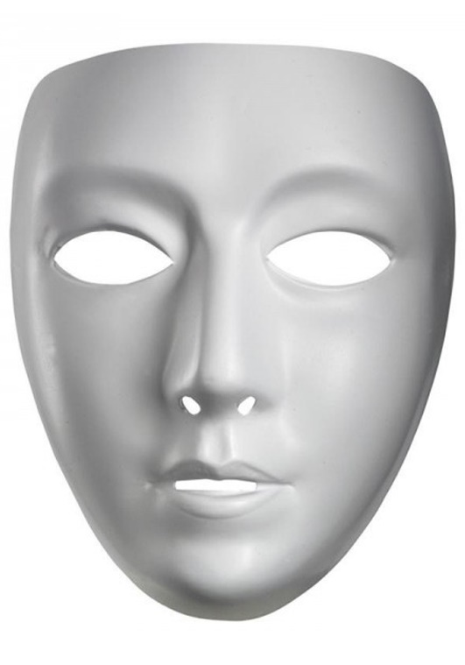

Step 4: Assessment – Self and Teacher

**English**

|  |  |  |  |  |
| --- | --- | --- | --- | --- |
| **Big Ideas:**   * Exploring text and story help us understand ourselves and make connections to others and to the world * Language and text can be a source of creativity and joy. | | | | |
| **Competency** | **B** | **D** | **A** | **E** |
| Assess and refine texts to improve their clarity, effectiveness, and impact. |  |  |  |  |
| Construct meaningful personal connections between self. |  |  |  |  |
| Exchange ideas and viewpoints to build shared understanding and extend thinking. |  |  |  |  |
| Recognize how language constructs personal, social, and cultural identity. |  |  |  |  |
| Use writing and design processes to plan, develop, and create engaging and meaningful informational texts. |  |  |  |  |

**Social Studies**

|  |  |  |  |  |
| --- | --- | --- | --- | --- |
| **Competency** | **B** | **D** | **A** | **E** |
| Determine what is significant in an account, narrative, and text. |  |  |  |  |
| Make ethical judgments about past events, decisions, and actions, and assess the limitations of drawing direct lessons from the past. |  |  |  |  |