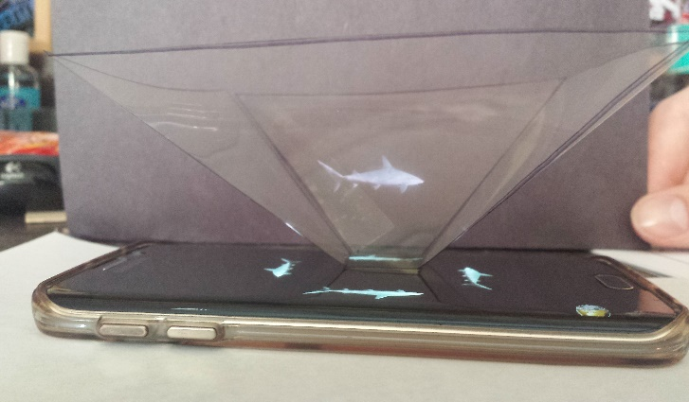
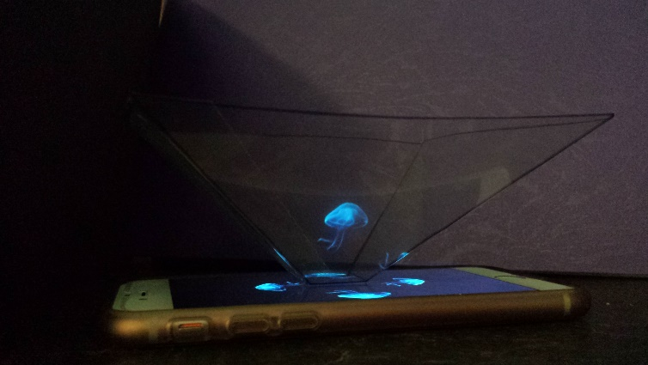
How to make your very own Hologram!

Materials Needed:

- Graph Paper
- Pencil/Pen
- Sharpie Marker
- Overhead Transparency Sheet
- Scissors
- Tape

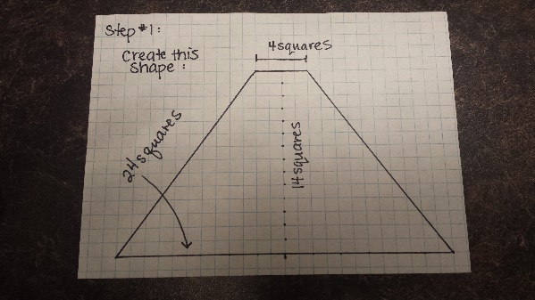
Instructions:
- Create a this trapezoid on the graph paper provided

- Trace the trapezoid on to the transparency sheet.
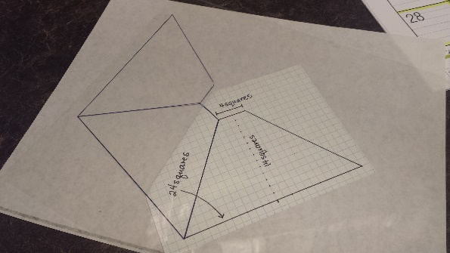
- Repeat step 2 three times. Connect each trapezoid by overlapping one line.

- You should have four connected trapezoid in total.
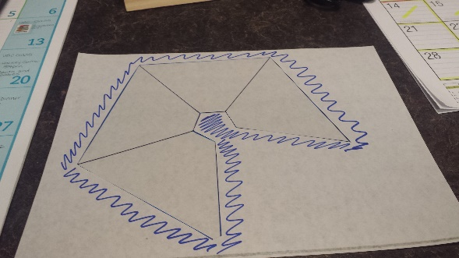
- Cut the new shape out. DO NOT CUT along the inside lines – just the outside.

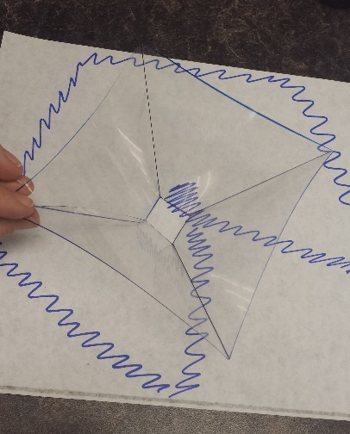
- Fold along the inside lines. Make sure the folds are all the same way to create an upside down pyramid shape (no top)

- Place a piece of tape along the final two edges to connect them. There shouldn’t be any overlap.

- YouTube search on your phone “Hologram Videos”

- Choose one and place your new hologram device on top in the center (ish) – you may want to move the device around to make the image pop off your phone more.

- Turn off the lights/find a dark room and gaze in awe at your new hologram.
