Social Studies – Geography
What is Geography?
- The study of the Earth: its land, features, inhabitants, and phenomena
Geography is divided into two major branches:
- Physical geography (land, features, phenomena)
- Human geography aka cultural geography (inhabitants; immigration, migration)

Physical Geography
Continents
  - Africa
  - North America
  - Antarctica
  - Asia
  - Europe
  - Australia
  - South America
Oceans
- Indian Ocean
- Pacific Ocean
- Atlantic Ocean
- Arctic Ocean

Latitude & Longitude
Latitude: Lines that run horizontal along the map (East and West)
- They are measured North and South from the Equator.
- The major line of latitude is the Equator it’s at 0º
Longitude: Lines that run vertical (up and down) along the map (North and South)
- They are measured East and West from the Prime Meridian (0º)
- The opposite of the Prime Meridian is the International Date Line (180º)

Geography Notes Continued…
- A circle (or a globe) has 360⁰. Each degree is divided into 60 minutes (‘) and then again into 60 seconds (‘’)
Hemispheres
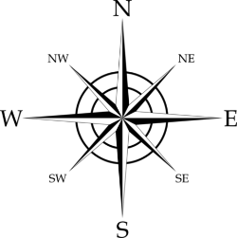

When reading and interpreting geographic coordinates, Latitude is ALWAYS written first.
But First, a little Math…

