FreshGrade – How To’s
Step 1
Log in to FreshGrade using your account. It’s easier if you use an actual computer rather than your phone app.
What kind of document are you uploading? Read the appropriate Step 2 for the type of document you are submitting: Word/PDF, or a Google Doc.
Step 2 – To upload a Word or PDF document
Uploading a Word Document
- Click on the Assignment you want to upload.  - Click “Edit”  - Click “+ Upload Files”  - Find your file, double click  - Click SAVE  - Repeat for the other assignments | 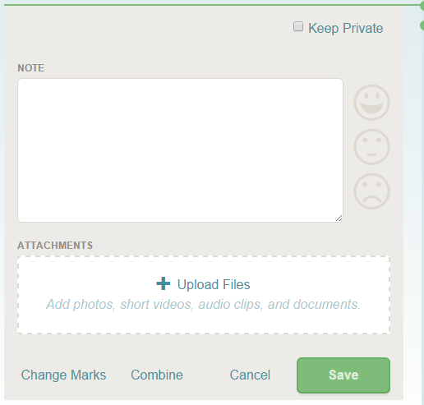
Step 2 – Attaching a Google Doc
Uploading a Word Document
- Click on the Assignment you want to upload.

- Click “Comment”

- Open up your Google Drive in a different tab.

- Find your Google Doc and open it.

- Click “Share” – blue button in the right hand corner.

- Click “Get Shareable Link”

- Adjust sharing capabilities so that “Anyone with the Link can

- Save

- Copy the link (by clicking either “Copy Link”; or Ctrl+C)

- Paste the link into the “Comment” section you opened earlier in FreshGrade

- Post Comment

- Repeat for the other assignments

Find me or Ms. Campbell sooner rather than later if you are having trouble.

