Humanities 8 with Ms. Citton is going on a field trip!
Parent & Student Information Sheet

Who: Ms. Citton’s Humanities Class (GH Block)
Chaperones: Ms. Citton, Ms. Sawatzky
What: Trip to the Vancouver Public Library: Hastings Branch
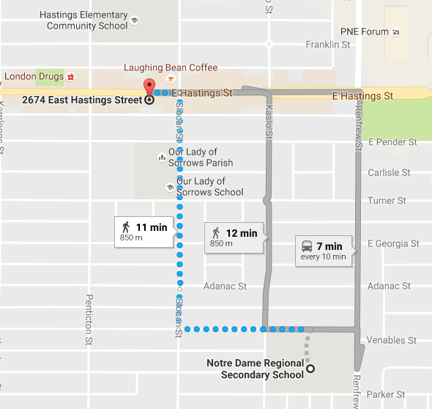
Where: Vancouver Public Library
2674 East Hastings Street
Vancouver, B.C. V5K 1Z6
When: Wednesday October 19th, 2016
Depart ND at 11:30am and arrive at VPL by 11:45am
Depart VPL at 1:00pm and arrive at ND by 1:15pm
*Students will be given time to eat lunch during H block.
How: Walking (approximately 12-15 minutes)
Why/Details:
We are starting a unit on short stories, and storytelling. The field trip will serve as the entry event into the unit.
After break, we will walk up to the VPL and spend some time in the children’s section. Students will be required to pick out a children’s book and share it with the class before returning to Notre Dame.
Please Bring/Wear:
- Students will be required to wear their uniforms; however, they may want to bring rain boots, rain coat, umbrella, hat etc. They need to be prepared for the weather.
- Completed Medical and Waiver form

