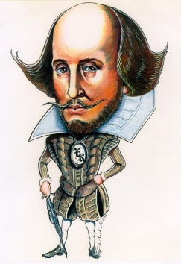
William Shakespeare Fact Find
Life and times:
- Where was Shakespeare born?

- What date did he die?

- What was the name for primary school in Shakespeare’s time?

- How many brothers and sisters did Shakespeare have?

- What were the names of his two sisters?

- How old was he when he died?

- What was the name of the house he retired to in Stratford upon Avon?

- What were the names of his 3 children?

- Name 3 subjects he studied at school.

- What was his mother’s maiden name?

Elizabethan England:
- What was the population of Stratford –Upon-Avon in Shakespeare’s time?

- Name 3 types of shops or stalls you would have found in an Elizabethan Town?

- What is Rother the old English word for?

- What were buildings made out of in towns in Elizabethan England?

- Where did Elizabethan people throw away their toilet waste?

- Which offences in Elizabethan England were dealt with by the Church Courts?

- What are Cheat and Manchet?

- What is sack?

- Descriobe Sack Posset.

- Apart from bread, what could you have for breakfast in Elizabethan England?

Elizabethan Theatre
- What were the cruel animal sports that the Elizabethans like to watch called?

- What were the other kinds of street theatre could you see in Elizabethan times?

- How many people could the Globe Theatre hold?

- What was Shakespeare’s theatre company originally called?

- When King James I was on the throne, what was Shakespeare’s theatre company called?

- What did Elizabethans actors use to recreate the effect of someone being stabbed?

- What did audiences do if they did not like a play?

- What were the people called who stood in the area at the front of the stage?

- How much did a ticket cost for a groundling?

- How was the sound of thunder recreated?

Shakespeare’s Works
- How many plays did Shakespeare write?

- What is his longest play?

- What are the names of the feuding families in Romeo and Juliet?

- Who does Miranda want to marry in The Tempest?

- What is the name of the Merchant of Venice?

- How do Romeo and Juliet die?

- What types of poems did Shakespeare write?

- What is the name of the money lender in the Merchant of Venice?

- What does he want in return for lending money to Antonio?

- What play is the famous Seven Ages of Man speech from?

