English 9
Ms. Citton
Lit Circles
For our first novel study, you will be selecting a book from titles we have on hand here at the school. Once you have made your selection, you will be placed into groups* according to the book you’ve selected. In your groups, you will determine a schedule to follow. The first day for discussion will be April 7. The last day will be May 4. For each Day 1, determine with your group which chapters you will be discussing in your lit circles those days. If, for example, I’m in a group that is reading The Outsiders, my group would probably divide that 180-page book into eight days of discussion so we could leave two lit circle days for working on our project. We’d probably figure on reading around 25 pages for each discussion period but would likely divide that up by chapter.
Each group will be responsible for putting together a presentation of their book, including some research into the author. We will discuss more details about this later.
Additional assessment tasks will include a literary paragraphs, making connections paragraphs, and journal responses. These will be completed individually and will be done in class.
The class format will be divided as follows: first 20 minutes for silent reading (AR) followed by 20 minutes of lit circles. You will peer and self-assess your participation in the discussions. The remaining 40 minutes of class will be spent on other tasks. These tasks may include both formal and informal writing, beginning some research of the author for your novel, prep time for your presentations, language conventions (grammar), and other Humanities tasks.
*Please note, if there are fewer than four students who have selected a particular book, those students may be asked to select a different one.

Summary
- Choose a book.
- Be placed into a group of students who will read the same book.
- Determine your reading schedule so discussion can begin April 7 and end May 4 (depending on how much time you want to set aside for project work).
- Summative tasks include one group project (presentation) and individual writing.
- Students will participate in determining the criteria for the presentations and will peer assess.
Sunday | Monday | Tuesday | Wednesday | Thursday | Friday | Saturday
March 29 | 30 | 31 | April 1 | 2 | 3  GOOD FRIDAY | 4
5  EASTER | 6  EASTER MONDAY | 7  Discussions begin | 8 | 9 | 10 | 11
12 | 13 | 14 | 15 | 16 | 17 | 18
19 | 20 | 21 | 22 | 23 | 24 | 25
26 | 27 | 28 | 29 | 30 | May 1  WALKATHON | 2
3 | 4  Discussions end | 5 | 6 | 7 | 8 | 9
10 | 11 | 12 | 13 | 14 | 15 | 16
March/April/May Calendar

Lit Circle Plan

Name: ________________________________________________
Novel/Team: _______________________________________________________
Members: ________________________________________________________________________
Date | Focus | Chapters/Pages | My Duties | My Peers’ Duties
April 7 | The Protagonist
April 9 | Setting
April 13 | Characters
April 15 | Author’s technique
April 17 | Genre
April 21 | Conflict
April 23 | Related Works
April 27 | Conclusions
April 29
May 4
May 6 | Paragraphs
May 8 | Presentations/Book Talk
Lit Circle Assessment

Name ____________________________________________________________
Team ____________________________________________________________

Self Peer Teacher

Criteria | Yes (2) | Somewhat (1) | No (0)
completed assigned reading before the start of class
fully prepared the material for assigned role
participated fully in discussion without dominating
brought all required materials to discussion
carefully listened to others during the discussion
responded to questions/comments
wrote a thoughtful journal response
responded orally to a peer’s journal response

Total: ___________/16

Materials to bring:
- Pens/pencils
- Novel
- Material pertaining to role: questions, summary, storyboard, vocabulary sheet
If you are going to be away, please send whatever material you are responsible for to your group.

Roles
Director/Questioner - Prepare at least 5 thoughtful questions that will lead to discussion and lead the discussion (refer to handout).
Illustrator- (part of director's duties in groups of 4) Draw something like a comic strip for the section of the book that you've read. Include all relevant information.
Summarizer - Prepare a summary of your section.
Vocabulary Builder - Find half a dozen words in your section. They can be words you are unfamiliar with or simply words you think are powerful. Complete the chart by writing the sentence you found the word in plus page number, identifying the part of speech, writing the definition as it is used in the section, and writing your own original sentence with the word.
Travel Tracer – Carefully track where the action takes place in the day’s reading.
Groups of 4: Eliminate Travel Tracer.
Groups of 5: You're in good shape.
Groups of 6: Add Researcher role: dig up background information on a relevant topic in the book.

Vocabulary Sheet – Lit Circles

Novel: _______________________________________ Team: ___________________________
Word | Sentence in Novel and Page Number | Part of Speech | Definition | Creative Sentence

Lit Circle Final Assessment
Name _________________________ Novel ________________________________
Self Peer ___________________________ Teacher
Criteria | Superior - 6 | Proficient - 5 | Competent - 4 | Adequate - 3 | Inadequate - 2 | Unacceptable - 1
completed all assigned reading before class | Every class, all readings done | Almost every class, all readings done | Most classes all readings done | Some classes all readings done | All readings done a few classes | Almost no reading done before classes
fully prepared the material for assigned role | Every class, all preparation done | Almost every class, all preparation done | Most classes, all preparation done | Some classes all preparation done | Some preparation done some classes | Almost no preparation done
participated fully in discussion without dominating | Every class, participated fully | Almost every class, participated fully | Participated fully most of the time | Participated most classes but not necessarily fully | Some participation | Very little participation
brought all required materials to discussion | Every class, all materials | Almost every class, all materials | Most classes almost all materials | Some materials some of the time | Rarely brought all materials | Missed at least one thing each class
carefully listened to others during the discussion | Every discussion | Almost every discussion | Most discussions | Some of the discussions | A few of the discussions | Almost none of the discussions
wrote thoughtful  journal responses | Each time | Almost every time | Most of the time | Some of the time | At least twice | No
contributed fully to project | Equally with other partners | Mostly equally | A fair share or a bit more than others | Almost all the project/very little | Hardly at all | Yeah….no

Total: ___________/42 Comments: _________________________________________________________________________________
_________________________________________________________________________________

Novel Presentations
Content: title, author, main characters, fun facts, summary, no spoilers, info about author, visuals (images)
Format: choice of – posters, Power Point, diorama, pamphlet, videos, Prezi, trailer, skit (any one or a combo of these choices)
Group Members: _________________________________________
Peer Assessor: ___________________________________________

Includes title and author
Includes all main characters
Includes at least one fun fact
Includes a good summary
Includes info about author
Visuals are appropriate and effort has been made
Presentation is shared equally
Voices are loud enough
Eye contact is made
Approximately 5 minutes (No penalty for exceeding.)

Presentation rubrics will be used along with this checklist.

Books to choose from:
In the Heat of the Night by John Ball, the Card turner by Louis Sachar, Touching Spirit Bear by Ben Mikaelsen, The Boy in the Striped Pajamas by John Boyne, The Bar Code Tattoo by Suzanne Weyn, Heaven is for Real by Todd Burpo, The Rosie Project by Graeme Simsion, The War Between the Classes by Gloria D. Miklowitz, and The Forest of Hands and Teeth by Carrie Ryan.
Some information about the novels (provided by goodreads.com):
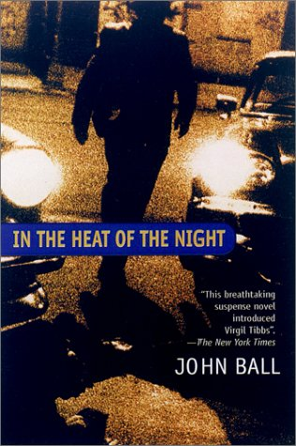
It's the 1960s. A hot August night lies heavy over the Carolinas. The corpse -- legs sprawled, stomach down on the concrete pavement, arms above the head -- brings the patrol car to a halt. The local police pick up a black stranger named Virgil Tibbs, only to discover that their most likely suspect is a homicide detective from California -- and the racially tense community's single hope in solving a brutal murder that turns up no witnesses, no motives, no clues.
185 Pages

The summer after junior year of high school looks bleak for Alton Richards. His girlfriend has dumped him to hook up with his best friend. He has no money and no job. His parents insist that he drive his great-uncle Lester to his bridge club four times a week and be his cardturner—whatever that means. Alton’s uncle is old, blind, very sick, and very rich.
But Alton’s parents aren’t the only ones trying to worm their way into Lester Trapp’s good graces. They’re in competition with his longtime housekeeper, his alluring young nurse, and the crazy Castaneda family, who seem to have a mysterious influence over him.
Alton soon finds himself intrigued by his uncle, by the game of bridge, and especially by the pretty and shy Toni Castaneda. As the summer goes on, he struggles to figure out what it all means, and ultimately to figure out the meaning of his own life.
336 Pages
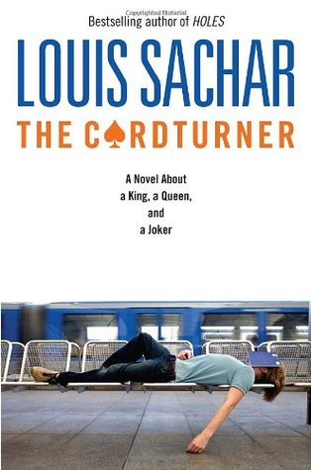

Within Cole Matthews lie anger, rage and hate. Cole has been stealing and fighting for years. This time he caught Peter Driscal in the parking lot and smashed his head against the sidewalk. Now, Peter may have permanent brain damage and Cole is in the biggest trouble of his life.
Cole is offered Circle Justice: a system based on Native American traditions that attempts to provide healing for the criminal offender, the victim and the, community. With prison as his only alternative, Cole plays along. He says he wants to repent, but in his heart Cole blames his alcoholic mom his, abusive dad, wimpy Alex--everyone but himself for his situation.
Cole receives a one-year banishment to a remote Alaskan island. There, he is mauled by Mysterious white bear of Native American legend. Hideously injured, Cole waits for his death His thoughts shift from from Anger to humility. To survive, he must stop blaming others and take responsibility for his life. Rescuers arrive to save Cole's but it is the attack of the Spirit Bear that may save his soul.
289 Pages

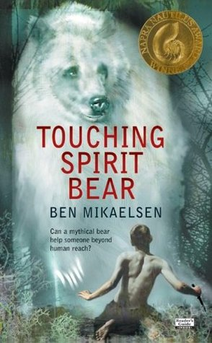
Berlin 1942
When Bruno returns home from school one day, he discovers that his belongings are being packed in crates. His father has received a promotion and the family must move from their home to a new house far far away, where there is no one to play with and nothing to do. A tall fence running alongside stretches as far as the eye can see and cuts him off from the strange people he can see in the distance.
But Bruno longs to be an explorer and decides that there must be more to this desolate new place than meets the eye. While exploring his new environment, he meets another boy whose life and circumstances are very different to his own, and their meeting results in a friendship that has devastating consequences.
224 Pages
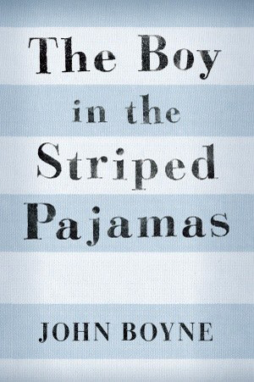

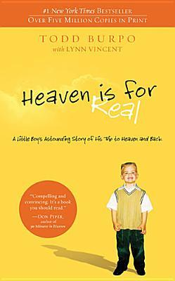
When Colton Burpo made it through an emergency appendectomy, his family was overjoyed at his miraculous survival. What they weren't expecting, though, was the story that emerged in the months that followed--a story as beautiful as it was extraordinary, detailing their little boy's trip to heaven and back.
Colton, not yet four years old, told his parents he left his body during the surgery-and authenticated that claim by describing exactly what his parents were doing in another part of the hospital while he was being operated on. He talked of visiting heaven and relayed stories told to him by people he met there whom he had never met in life, sharing events that happened even before he was born. He also astonished his parents with descriptions and obscure details about heaven that matched the Bible exactly, though he had not yet learned to read.
163 Pages

Individuality vs. Conformity. Identity vs. Access. Freedom vs. Control
The bar code tattoo. Everybody's getting it. It will make your life easier, they say. It will hook you in. It will become your identity.
But what if you say no? What if you don't want to become a code? For Kayla, this one choice changes everything. She becomes an outcast in her high school. Dangerous things happen to her family. There's no option but to run...for her life.
256 Pages

Don Tillman, professor of genetics, has never been on a second date. He is a man who can count all his friends on the fingers of one hand, whose lifelong difficulty with social rituals has convinced him that he is simply not wired for romance. So when an acquaintance informs him that he would make a “wonderful” husband, his first reaction is shock. Yet he must concede to the statistical probability that there is someone for everyone, and he embarks upon The Wife Project. In the orderly, evidence-based manner with which he approaches all things, Don sets out to find the perfect partner. She will be punctual and logical—most definitely not a barmaid, a smoker, a drinker, or a late-arriver.
Yet Rosie Jarman is all these things. She is also beguiling, fiery, intelligent—and on a quest of her own. She is looking for her biological father, a search that a certain DNA expert might be able to help her with. Don's Wife Project takes a back burner to the Father Project and an unlikely relationship blooms, forcing the scientifically minded geneticist to confront the spontaneous whirlwind that is Rosie—and the realization that love is not always what looks good on paper.
295 Pages
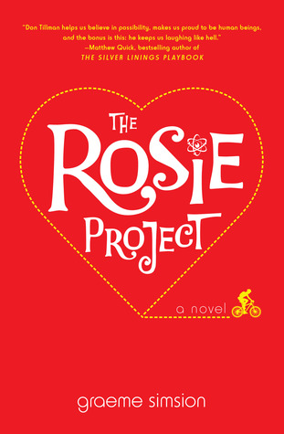

What are Amy and Adam going to do about their love life? Neither Amy's traditionalist Japanese parents nor Adam's snobby, upper-class mother will accept their relationship. To make things worse, Amy and Adam are involved in the "color game" at school, an experiment that's designed to make students aware of class and racial prejudices.
Now the experiment threatens to alienate Amy from her friends and tear her apart from Adam. She knows it's time to rebel against the color game. But will the rest of the class follow her lead?
176 Pages

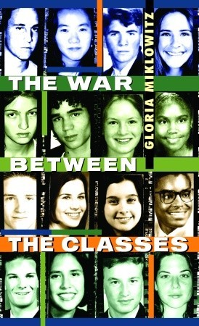
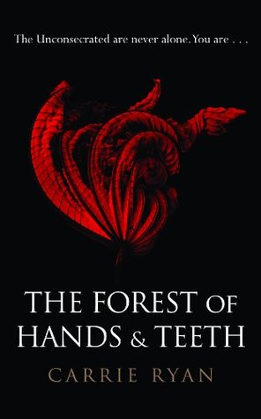
In Mary's world there are simple truths. The Sisterhood always knows best. The Guardians will protect and serve. The Unconsecrated will never relent. And you must always mind the fence that surrounds the village; the fence that protects the village from the Forest of Hands and Teeth. But, slowly, Mary’s truths are failing her. She’s learning things she never wanted to know about the Sisterhood and its secrets, and the Guardians and their power, and about the Unconsecrated and their relentlessness. When the fence is breached and her world is thrown into chaos, she must choose between her village and her future—between the one she loves and the one who loves her. And she must face the truth about the Forest of Hands and Teeth. Could there be life outside a world surrounded in so much death?
310 Pages

