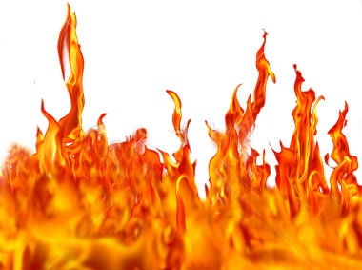
Through me the way into the suffering city,
Through me the way to the eternal pain,
Through me the way that runs among the lost.
Justice urged on my High Artificer;
My maker was Divine Authority,
The Highest Wisdom, and the Primal Love.
Before me nothing but eternal things
were made, and I endure eternally.
Abandon every hope, ye who enter here.
Dante’s Inferno
Inferno 3: 1-9

Name:

English with Ms. Citton

What to Expect
Over the next few weeks, we will go on a journey through the nine circles of hell according to Dante Alighieri.
You will have various small assignments and a culminating (final) project due on the last day of the unit. There will be a daily journal, debates, oral presentations, and more.
As we read the novel, please make notes and ask questions. This is a difficult text, and you will need to ask for clarification when it is needed. Use the website and resources available to you. When I ask you to read Cantos for homework – DO IT! Do not fall behind – we will leave you there.
The Story
Follow Dante and his guide, Virgil, on their journey through Hell. Enter the different realms and understand the sins that historical figures have committed; experience the punishment and retribution that Dante the poet has bestowed upon these souls, and seek forgiveness for yourself.
Materials:
Because of the nature of this novel, you will need:
- A pack of sticky notes and/or flags to help you remember important things.
- A pen/pencil
- The book - if you wish to purchase your own novel, you are free to do so; however, look for the same version! There are multiple translations of the text and some are more difficult than others.
PLEASE DO NOT WRITE IN THE BOOK!

Assignments
1. Double-Entry Journal – Daily Entry
The Purpose:
The goal of this assignment is to allow you to process and explore what you are reading, studying and observing and connect it with the rest of your experiences, thoughts, and feelings. The benefit of this assignment is that it allows you to actively involve yourself in the ideas and subject matter of the Novel by writing, and talking about what you are reading and experiencing in class. This assignment also allows you to develop your own analogies and metaphors.
Requirements:
You are required to keep an up-to-date* double entry journal that I will be checking at least once a week until the novel is finished.
A double entry journal is a special type of learning log in which the pages are divided into two columns. You will write different types of information in each column:
COLUMN #1  In the left column, you will write the questions provided, quotes or statements from the readings, class lectures, presentations, demonstrations, and observations.  This column may also be used to summarize what you read. | COLUMN #2  In the right column, you will reflect on each quote or statement, or answer the questions provided.  You may relate the quote or statement to your own background knowledge, react to it, write a question, or make some other connection.  Critical reflection on your learning is what is important - do not worry about length. *It is, however, expected that you will write a maximum of 400 words PER entry.

**Word of advice: DO NOT PROCRASTINATE! Stay on top of these entries!

2. In-class assignments
Throughout the unit you will be required to write, act, speak, debate and discuss the readings and concepts. Your participation, preparedness, and contribution will be evaluated. Stay engaged with the material, ask questions, research and make connections etc. and you will do well.

3. Final Project – Choose ONE of the following. 60 marks
For the culminating project you may choose to work by yourself or in a pair. Choose one of the following projects – presentations and presentation order will be determined at a later date.

Choice 1: Movie Maker Individual or Pair
Choose your favorite sin or canto. Write a screenplay and script for the canto; cast it; and film it. Post it as a YouTube video on your website.
Choice 2: Musical Artist Individual or Pair
Choose your favorite sin or canto. Assume the novel is being turned into a musical. Write a song (min. 3 verse + 1 chorus) about the sin and punishment. Record the song and post it on your website.
Choice 3: Architects Individual or Pair
Build a 3D model of Hell or your favorite circles (min. 2)
Choice 4: Artists and Writers Individual or Pair
Create a comic strip or graphic novel (either by hand or online) of Dante’s Inferno.
Choice 5: Actors Individual
Choose your favorite sin or canto. Write and perform a Dramatic Monologue or Soliloquy of the sin/canto. You may choose to either film it or perform it live in class.
Choice 6: Travel Narrative or Guidebook Individual or Pair
Create a Travel Narrative or Guidebook through Hell with images and pieces of writing to help anyone else who is planning to travel through Hell.

Choice 7: Facebook Individual or Pair*
Choose either Dante or Virgil. Create a Facebook folder for them and log their journey through Hell.
*If you choose to this in a pair, one of you will be Virgil, and one will be Dante.
Choice 8: Writers Individual or Pair
Using the newspaper, find an article or news story that features an individual who has committed multiple sins. In an essay (500-1000 words), discuss which circle this individual would be in and justify your decision. Discuss the punishment and 1 possible counter argument.
Choice 9: Be Creative Individual or Pair
Have your own project idea? Come see me!

For Full Description, Criteria, and Assessment – Keep flipping.

Project Ideas: Full Description
Choice 1: Movie Maker Individual or Pair
Choose your favorite sin or canto. Write a screenplay/script for the canto; cast it; and film it. Post it as a YouTube video on your website.
Requirements
The canto you choose for this assignment must be a significant one in the novel. It should incorporate: the sin, the punishment, and at least one important historical figure.
When choosing a canto, be sure to have a vivid picture in your mind. You will be need to articulate what you see, feel, and sense to help the scene come to life. Director’s notes and thoughts will need to be clear for when you direct your film. This is your vision – make it come to life!
Screenplay/Script:
The screenplay/script needs to be as detailed as possible using evidence from the novel. Elements such as lighting, costuming, setting etc. will also need to be considered. The dialogue needs to be clear and demonstrate an understanding of the canto. Length is irrelevant – the screenplay needs to encompass the entire canto and therefore should be as long as you deem fit.
Casting:
You may choose to direct AND star in your feature, or just direct – it’s up to you. Casting is a very important aspect of film making and because this is your vision, you may cast who you want – so long as they are ok with it.
Should you ask your friends and/or family to help you, rehearsals and memorization are important. The acting should be believable and professional.
Film:
Length – as long as it needs to be.
There are a variety of tools you can use to create your video. If you are using a Mac, the “Movie Maker” application is helpful. A title, smooth transitions, and end credits need to be included. Editing is a very important part of film making – take the time!
Mr. Vogel, Mr./Mrs. Isherwood, and I will be great assets and good people to ask for help – especially in the editing stage!
Movie Maker
For an A | For a B | For a C
- The screenplay is detailed and uses explicit details from the novel to create a vivid picture in the reader’s mind.  - The script is logical and follows the narrative closely.  - The film follows the screenplay closely.  - Casting is well done.  - Actors are well rehearsed.  - Mood and tone are created in the scenery and actors. They match the screenplay and novel and are effective.  - Setting is planned and matches the novel.  - Transitions are smooth.  - Filming is smooth.  - YouTube video is posted online and the video can be played without difficulty. | - The screenplay is detailed and uses many details from the novel to create an adequate picture in the reader’s mind.  - The script is logical and attempts to follow the narrative.  - The film follows the screenplay.  - Casting is ok.  - Actors are rehearsed, but may stumble.  - Mood and tone are created but may not be effective.  - Setting is planned and matches the novel.  - Transitions are smooth.  - Filming is smooth.  - YouTube video is posted online but a login may be required. | - The screenplay lacks details and uses only the most obvious details from the novel. The reader my understand where it’s “supposed” to go, but the imagery is lacking.  - The script is illogical but tries to follow the narrative.  - The film attempts to follow the screenplay.  - Casting is questionable.  - Actors require cue cards/prompts.  - Mood and tone are weak.  - Setting is unplanned and may not match the novel.  - Transitions are rocky.  - Filming is rocky.  - YouTube video is not posted online but the link is sent to Ms. Citton. The video can be played without difficulty.

Assessment:

Screenplay/Script /35
Grammar/Mechanics (5)
Details/Support (30)
Film /25
Transitions (5)
Tone/Mood (5)
Setting (5)
Casting/Acting (5)
Editing (5)

Total: /60

Choice 2: Musical Artist Individual or Pair
Choose your favorite sin or canto. Assume the novel is being turned into a musical. Write a song (min. 3 verse + 1 chorus) about the sin and punishment. Record the song and post it on your website.
Requirements
Novels are often turned into musicals because music has a way of capturing a variety of emotions all the while telling a story.
For this assignment, you will assume that Dante’s Inferno is being turned into a musical. Your task is to choose one canto and write a song that captures the emotions, the sin, and the punishment involved. Your song can summarize the canto or serve as a warning to listeners.
Lyrics:
Your song must be at least 3 verses in length and include a chorus. These lyrics will be typed out and handed in on February 20th. Follow MLA format.
Music:
You may choose to write your own music and make it an original composition. Perhaps as you are reading a tune comes to mind.
Or
You may choose to use music that already exists and change the lyrics to fit.
Recording*:
You do not have to sing your own song – you may ask a friend/family member to sing the song for you. However, be sure to give them credit at the end of your recording.
There are many tools you may wish to use to record your song and post it. You can do it as an audio file or create a music video. Either way, the link to the recording must be posted on your website by the deadline.
*The Garage Band program is very easy to use.

Mr. Vogel, Mr./Mrs. Isherwood, and I will be great assets and good people to ask for help – especially in the editing stage!
Musical Artist
For an A | For a B | For a C
- The song is an original composition.  - The song talks about the sin and the punishment in detail.  - The song uses details from the novel to support the lyrics.  - The song has a minimum of 3 verses and 1 chorus.  - Singer is well rehearsed.  - Mood and tone are created by the music and singer’s voice. It is very effective.  - Transitions are smooth.  - A music video is created to go with the song.  - Lyrics are typed out and submitted.  - YouTube video is posted online and the video can be played without difficulty. | - The song uses already created music, but the lyrics are different.  - The song talks about the sin and the punishment with some detail.  - The song uses details from the novel to support the lyrics.  - The song has 2 verses and 1 chorus.  - Singer is rehearsed.  - Mood and tone are created by the music and singer’s voice. It is effective.  - Transitions are smooth.  - There is no music video.  - Audio is posted online but a login may be required. | - The song uses already created music, but the lyrics are different.  - The song talks about the sin and the punishment.  - The song uses the most obvious details from the novel to support the lyrics.  - The song has 1 verse and 1 chorus.  - Singer is under rehearsed.  - Mood and tone are weak and may not match.  - Transitions are shaky.  - There is no music video.  - Audio is not posted online but the link is sent to Ms. Citton. The video can be played without difficulty.

Assessment:
Song /40 Total: /60
Sin (10)
Punishment (15)
Details/Support (15)
Audio /20
Credits (5)
Emotion/Sound (5)
Recording Quality (10)
Choice 3: Architects Individual or Pair
Build a 3D model of Hell, or your favorite circles (min. 2).
Requirements
Using figurines, labels, and other materials, build a 3D model of Hell. You may use any materials you like. Be sure to plan out your model!
The model should stand alone (without assistance) and include all the levels of Hell (9 circles, the vestibule, and the dark wood). Use details and quotes from the novel to create an informative and complete model. Be sure to include as many of the important figures as possible – you do not need to include all of the people Dante meets.
For Inspiration:
http://www.youtube.com/watch?v=b6cx4Y3MtaA
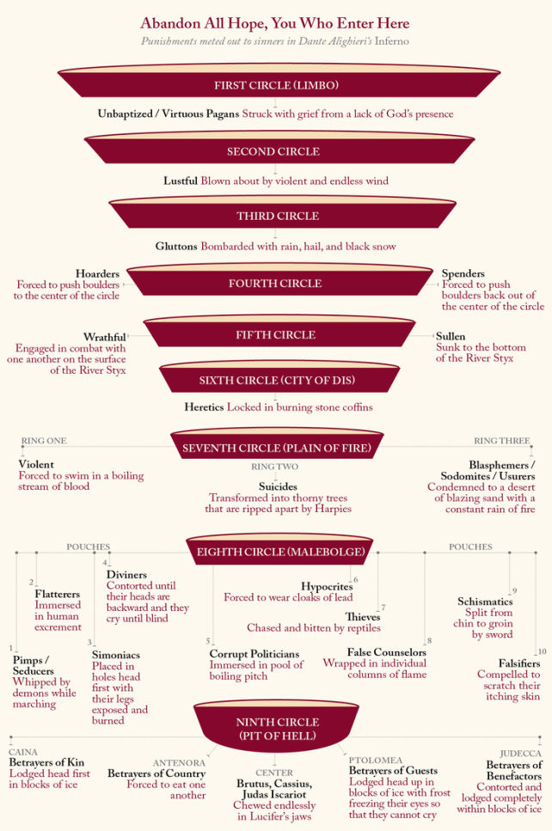
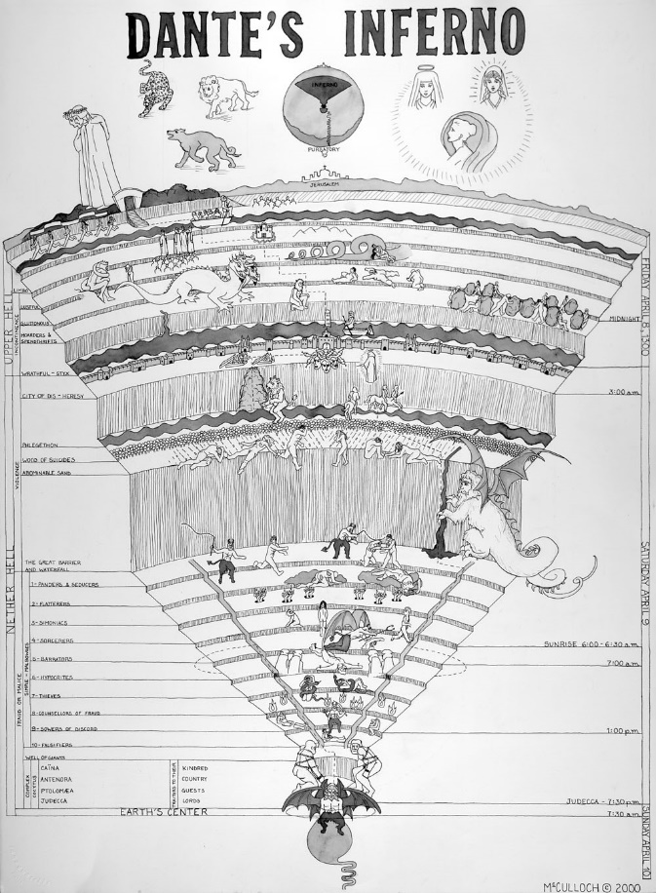

3D Model
For an A | For a B | For a C
- The model is planned out; well-spaced, and sturdy.  - The model includes all nine circles of hell (all of circle 7 and 8 are included), limbo, the vestibule, and the dark wood.  - The model is extremely detailed and the easy to follow.  - The model uses many details from the novel to help construction.  - The model includes all major characters/figurines to help the audience understand the sin/punishment/images.  - The model includes “name-tags” for clarification.  - The model is brought to school on the due date and requires very little set up or “fixing” before presentation. | - The model is planned out and sturdy.  - The model includes the nine circles of hell.  - The model is detailed and the relatively easy to follow.  - The model uses details from the novel to help construction.  - The model includes most of the major characters/figurines to help the audience understand the sin/punishment/images.  - The model is brought to school on the due date but requires set up or “fixing” before presentation. | - The model is 2D (hand drawn on paper).  - The drawing includes at least 6 circles of hell (sections of circle 7 and 8 may be combined)  - The drawing detailed but hard to follow.  - The model uses some details from the novel to help construction.  - The drawing includes some characters/figurines to help the audience understand the sin/punishment/images.  - The drawing is “left at home” on the due date, but brought asap.

Assessment:
Model /60 Total:
Circles (15)
Aesthetics/Structure (15)
Details/Support (30) /60

Choice 4: Artists and Writers Individual or Pair
Create a comic strip or graphic novel (either by hand or online) of Dante’s Inferno.
Requirements
Comic Strips and Graphic Novels are created to help the audience follow the story and imprint vivid images in the audience’s mind. For this project, you will create a comic strip or graphic novel that follows Dante’s journey through Hell.
Comics/Graphic Novels
Comic strips and graphic novels use a lot of dialogue and images to tell stories. Your task will be to convert the text into this medium. Each canto should feature 4-5 images and pieces of text that tell the story. Important elements, features, quotes, and details need to be included.
Formatting
You may wish to use an online comic builder like bitstrips.com or pixton.com or draw it freehand. Both are acceptable. Both need to be easily accessible and handed in (either in hardcopy or via online link) on the due date.
Idea: If you choose to do the comic by hand, or print your electronic comic, I can show you how to make it into a book with a cover and binding.
For Inspiration
http://www.pixton.com/comic/fff26mjf

Comic Strip/Graphic Novel
For an A | For a B | For a C
- The comic/graphic novel is planned out; well-developed and very detailed.  - The comic/graphic novel includes the entire journey - all nine circles of hell (all of circle 7 and 8 are included), limbo, the vestibule, and the dark wood.  - The comic/graphic novel is extremely detailed and follows the novel.  - The comic/graphic novel uses many details from the novel to help the illustrations.  - The comic/graphic novel includes all major characters to help the audience understand the sin/punishment/images.  - The comic/graphic novel includes well-written, detailed, and pertinent text and speech bubbles to direct the story and help the audience.  - If the comic/graphic novel is done by hand, it is handed in on time;  - If comic/graphic novel is done online, the link is posted online. | - The comic/graphic novel is planned out; developed and detailed.  - The comic/graphic novel includes the entire journey - all nine circles of hell (circle 7 and 8 are not be separated), limbo, the vestibule, and the dark wood.  - The comic/graphic novel is detailed and attempts to follow the novel.  - The comic/graphic novel uses details from the novel to help the illustrations.  - The comic/graphic novel includes most of the major characters to help the audience understand the sin/punishment/images.  - The comic/graphic novel includes well-written text and speech bubbles to direct the story and help the audience.  - If the comic/graphic novel is done by hand, it is handed in on time;  - If comic/graphic novel is done online, the link is posted online. | - The comic/graphic novel is unplanned; seems rushed and lacks detail.  - The comic/graphic novel includes most of the journey - all nine circles of hell are included (circle 7 and 8 are not be separated).  - The comic/graphic novel lacks details and attempts to follow the novel.  - The comic/graphic novel uses few details from the novel to help the illustrations.  - The comic/graphic novel includes Dante and Virgil as characters to help the audience understand the sin/punishment/images.  - The comic/graphic novel includes text and speech bubbles to direct the story and help the audience.  - If the comic/graphic novel is done by hand, it is handed in 1 day late;  - If comic/graphic novel is done online, the link is posted online late.

Assessment:
Comic/Graphic Novel Total: /60
Graphics (10)
Writing (15)
Details/Support (30)
Completion (5)

Choice 5: Actors Individual
Choose your favorite sin or canto. Write and perform a Dramatic Monologue or Soliloquy of the sin/canto. You may choose to either film it or perform it live in class.
Requirements
Dramatic monologues and soliloquys are used in dramas to express a character’s in most thoughts and deepest feelings. For this assignment, you will choose your favorite canto – one where Dante experiences true turmoil and distress. You morph the text into a dramatic monologue or soliloquy of at least 100 words.
What’s the difference between a dramatic monologue and soliloquy?
Dramatic Monologue: a verse composition where the speaker reveals his or her character – how they are feeling, what experiences they have had, in relation to a critical situation or event. The monologue is usually addressed to the audience – the speaker is aware of the audience.
Soliloquy: an verse composition of the speaker’s inner thoughts regardless of any hearers – there is no audience. Essentially, the speaker is talking to him/herself.
Written:
You will draft and hand in a typed copy of your monologue using MLA format. Be sure to use details from the story to invoke emotion and create mood. You can change the language and use modern day language and situation to help you express your ideas and take on the canto.
Presentation:
Your choice: you can either perform your monologue live, or you can film it and present it to the class. In either case, the monologue should be rife with emotion and logical details and inferences. Refer to the rubric and A, B, C suggestions.
Should you choose to film your monologue, come see me for ideas and feedback.

Mr. Vogel, Mr./Mrs. Isherwood, and I will be great assets and good people to ask for help – especially in the editing stage!

Monologue
For an A | For a B | For a C
- The monologue is well-written, typed and grammatically correct.  - The monologue follows MLA format.  - The monologue is original and at least 250 words. Written script will be handed in.  - The monologue is performed via an excellent, and edited video recording via YouTube.  - The monologue is performed with appropriate tone, emphasis, and emotion.  - The monologue encompasses the entire canto – beginning, middle and end.  - The monologue is reflective in nature and describes the speaker’s feelings, conquests, fears, concerns etc. | - The monologue is well-written, typed with few grammatical errors.  - The monologue follows MLA format.  - The monologue is original and at least 150 words. Written script will be handed in.  - The monologue is performed live.  - The monologue is performed with feeling and emotion.  - The monologue encompasses most of the canto.  - The monologue attempts to be reflective in nature and describes the speaker’s feelings, conquests, fears, concerns etc. | - The monologue is typed with many errors that may impede meaning.  - The monologue does not follow MLA format; but is neat.  - The monologue is original and at least 100 words. Written script will be handed in.  - The monologue is not performed live or via film but handed in.  - The monologue is performed without feeling and emotion.  - The monologue encompasses most of the canto.  - The monologue is not reflective in nature; but a summary of the canto.

Assessment:
Monologue – Written /45 Total:
Conventions/Grammar (5)
Length (5) /60
Reflection/Summary (15)
Details/Support (20)
Monologue – Performance /15
Tone/Emotion/Feeling (10)
Delivery (5)
Choice 6: Travel Narrative or Guidebook Individual or Pair
Create a Travel Narrative or Guidebook through Hell with images and pieces of writing to help anyone else who is planning to travel through Hell.
Requirements
We’ve all see the Travel Guidebooks, and the “Idiot’s guide to…” or the “…for Dummies” books. Now it’s your turn to write one. For this assignment you will write an travel narrative or guidebook for anyone else who’s planning to travel through Dante’s Hell.
Travel Narrative:
Travel narratives are usually fictitious and engage the reader using narrative elements. In reality, Dante’s Inferno is a travel narrative – it is about Dante’s journey through Hell. Your task is to create your own travel narrative as though you are with Dante – what are YOU feeling, and sensing? What do your surroundings look like, smell like, feel like? You can incorporate class discussions, ideas, and double entry journal to help you.
The narrative is your story, your journey through Hell.
Length is up to you.
Guidebook:
Before starting your guidebook, read a couple or flip through a few at your local chapters/indigo. Every guidebook is unique and targets a specific group of people. For example:
A family-oriented guidebook will emphasize theme parks, child-oriented museums and activities, informal restaurants etc.
A student-oriented guidebook will cover youth hostels, affordable restaurants, clubs, and concerts etc.
A history and sightseeing guidebook won’t have “updated” information, but focus on the location of significant historical facts, monuments, and museums.
The guidebook should include details from the story, images and “fun facts.” Length is up to you. Each canto (sin and punishment) need to be included; as do important figures and their significance – you do not need to include every person Dante meets.
Presentation:
Book format. Come see me when you are ready and I can teach how to make a book.
Travel Narrative/Guidebook
For an A | For a B | For a C
- The Travel Guide is well-written, typed and grammatically correct.  - The Travel Guide follows MLA format.  - The Travel Guide is original.  - The Travel Guide includes a variety of images and appropriate written portions that correspond to the novel (chronologically correct).  - The Travel Guide includes an introduction and conclusion.  - The Travel Guide outlines and encompasses the entire novel – important details, persons, and facts are included.  - The Travel Guide uses the explicit details to support and drive the guide.  - The Travel Guide is in book format and looks “legit.”  - The Travel Guide is informative and professional. | - The Travel Guide is well-written, typed with few grammatical errors that do not impede meaning.  - The Travel Guide follows MLA format.  - The Travel Guide is original.  - The Travel Guide includes a few images and written portions that correspond to the novel.  - The Travel Guide outlines and encompasses the entire novel with most of the important details, persons, and facts included.  - The Travel Guide uses the many details to support and drive the guide (some details may be missing).  - The Travel Guide is handed in as a manuscript.  - The Travel Guide is informative. | - The Travel Guide is hand written with many grammatical errors that may impede meaning.  - The Travel Guide does not follow MLA format.  - The Travel Guide includes a few images and written portions that correspond to the novel.  - The Travel Guide outlines and encompasses most of the novel.  - The Travel Guide uses the few details to support and drive the guide (many details may be missing).  - The Travel Guide is handed in late.  - The Travel Guide attempts to be informative.

Assessment:

Travel Guide – Written /40
Conventions/Grammar (5)
Details/Support (20)
Aesthetics (5)
Completion (10)
Travel Guide – Images /20
Appropriateness (10)
Quantity (10)
Total /60

Choice 7: Facebook Individual or Pair*
Choose either Dante or Virgil. Create a Facebook folder for them and log their journey through Hell. (2 ½-3 Facebook pages: About Me (½ ) , News Feed (1), and Wall (1-2).
*If you choose to this in a pair, one of you will be Virgil, and one will be Dante. You will comment on each other’s pages.
Requirements
Using the folder provided, you will create two and a half (2½-3) Facebook pages for either Dante or Virgil (if you are working as a pair, you will be both characters).
The purpose of this assignment is to demonstrate an understanding of the character, the story, and how the different characters interact with one another.
Front Cover (½ page) “ABOUT ME”
- Profile picture
- Basic Information (relationship status, sex, network, interested in)
- Contact Information (address, screen name, email, philosophy etc.)
- Sports
- Arts and Entertainment (fav. books, movies, songs etc.)
- Activities and Interests
Inside Cover (left side) “NEWS FEED”
- Profile picture
- Name
- 10-15 significant “posts” (status updates of friends, wall posts, comments etc.)
Inside Cover (right side/back side) “THE WALL”
- Profile picture
- Name
- Basic Information (birthday, hometown, relationship status, etc.)
- 5-8 Friends and/or Family
- 10-15 significant “posts” (status updates, wall posts, comments etc.)
*The Wall should follow Dante’s journey and feelings throughout Hell.
The wall posts should be in full, complete sentences and avoid “txting” language (an LOL here and there is all right). Colloquial/everyday language is ok, but keep it clean – this is Facebook, but it’s also English Class.
Read the rubric carefully. You may have to infer from the readings to fill in certain sections.
Facebook
For an A | For a B | For a C
- The folder includes all required elements, as well as additional information and/or features.  - There are no grammatical errors. Language is appropriate and creative.  - The profile is exceptionally attractive in terms of design, layout, and neatness.  - All status updates are informative and creative. They demonstrate a clear, solid understanding, and thoughtful analysis, about the novel and character.  - All profile pictures, icons, and artwork are appropriate and illustrate an understanding of character traits.  - The ½ page is complete with details from the novel.  - The news feed/wall follow and comment on the entire novel – all major events and people are included. | - The folder includes most of required elements.  - There are very few grammatical errors. Language is appropriate.  - The profile is attractive in terms of design, layout, and neatness.  - All status updates are informative. They demonstrate an understanding, thoughtful analysis, and logical inferences about the novel and character.  - All profile pictures are appropriate and illustrate an understanding of character traits.  - The ½ page is complete with details from the novel.  - The news feed/wall follow and comment on most of the novel – many major events and people are included (some events and people may be missing). | - The folder is missing many of the required elements.  - There are many grammatical errors that may impede meaning. Language is appropriate.  - The profile attempts to be creative in design, layout, and neatness.  - Some status updates are vague or do not clearly illustrate an understanding of the myths and characters.  - Some of the profile pictures are relevant, but do not illustrate an understanding of character traits.  - The ½ page is almost complete with few details from the novel.  - The news feed/wall follow and comment on some of the novel – many major events and people are missing.

Assessment:
Grammar/Mechanics (10)
Presentation/Aesthetics (5)
Status Updates: Details/Support (20)
Graphics: pictures, icons etc. (5)
Required Elements (5)
Character Information (10)
Completeness: novel coverage (5)
Total: /60
Choice 8: Writers Individual or Pair
Using the newspaper: find an article or news story that features an individual who has committed multiple sins. In an essay (500-1000 words), discuss which circle this individual would be in and justify your decision. Discuss the punishment and 1 possible counter argument.
Requirements
Every day we hear about different people, or groups of people, who have committed sins and/or crimes. For this assignment, you will act as judge and jury and condemn souls to a circle of Hell.
Using the newspaper or gossip magazine, choose an article/story that features an individual or group of people who have committed more than one sin. In an essay (500-1000 words), discuss which circle the sinners are condemned to and justify your decision with specific reference to the novel (quotes). As well, discuss the punishment and at least 1 possible counter argument (is there another circle they may belong too?).
Possible Structure:
- Introduction – Briefly talk about Dante’s Inferno and the article in question. Thesis: “Name” belongs in the 7th circle of Hell because he/she committed these sins: 1, 2, 3.
Thesis Example: Chris Brown belongs in the first round of the 7th circle of Dante’s Hell where he will forever swim in the boiling blood of Phlegethon for his crimes against others.
- Body #1: summarize the article and the people involved. The sins of the accused.
Example: Chris Brown is an American recording artist, dance, and actor. He dabbles in R&B, hip hop, and dance. He has six successful albums: Chris Brown, Exclusive, Graffiti, and F.A.M.E and Fortune, and X. While this artist may seem successful, he has led a life of sin and will undoubtedly end up in the 7th circle of Dante’s Hell. Chris Brown has a history of violence against others including musical artist Rihanna. [Outline other sins]
- Body #2: summarize the circle – sin, punishment, who else might be there etc. AND why it’s a good fit for the sinner.
Example: Dante’s 7th circle is divided into three levels: the boiling river of blood for those who commit acts of violence against others, the wood of suicides for those who commit acts of violence against themselves, and the Plain of Burning sand for those who commit acts of violence against God. [Continue and focus on the first round].
- Body #3: Counter-Argument (which other circle might this person belong too); end this paragraph with a rebuttal.
Example: Chris Brown could also be condemned to the 8th circle of Dante’s Hell. He could be found in the final ring of the Malebolge with the Falsifiers. He is a falsifier of words and has lied to the courts and others – specifically in regards to his community service hours. He was credited with hours without even being in the United States. However, while this sin is more treacherous than his violence against others, the pattern of behaviour speaks to a continued vice in hurting others and therefore he should be doomed to boil in their blood and pain. [To be continued..]
- Conclusion: Summarize the arguments, restate your thesis and answer the “So What” question.
Hand in:
- Final copy of the essay (MLA format; include word count at the bottom of the last page)
- The newspaper/magazine article
- Works Cited (MLA format)
For an A | For a B | For a C
- The essay skillfully establishes a context and engages the reader.  - The essay advances an insightful or complex thesis and develops a controlling idea that addresses the prompt.  - The essay effectively supports valid arguments with detailed evidence, citing sources of information when appropriate.  - The essay analyzes at least 1 counterpoint and advances respective rebuttals.  - The essay uses several strategies to persuade.  - The response is skillfully organized from beginning to end. Contains an opening, body, and closure that are complex.  - The essay demonstrates consistent control of grammar, usage, punctuation, sentence construction, and spelling. | - The essay clearly establishes a context and engages the reader.  - The essay advances a valid thesis and develops a controlling idea that addresses the prompt.  - The essay supports valid arguments with detailed evidence, citing sources of information when appropriate.  - The essay analyzes evidence in relation to the thesis.  - The essay may attempt to address a counterpoint and advances respective rebuttals.  - The essay uses at least 1 strategy to persuade.  - The response is clearly organized from beginning to end. Contains an opening, body, and closure.  - The essay demonstrates consistent control of grammar, usage, punctuation, sentence construction, and spelling.  - Occasional errors do not usually interfere with meaning. | - The essay attempts to establish context and engage the reader.  - The essay advances an incomplete thesis or controlling idea in relation to the prompt.  - The essay attempts to support arguments but some evidence lacks clarity, accuracy, or correct citation.  - The essay lacks clarity in analysis.  - The essay lacks a clear counterpoint and/or rebuttal.  - The essay uses unclear or ineffective strategies to persuade.  - The response includes an opening, body and closer; however one or more of these elements is not fully developed.  - The essay demonstrates some control of grammar, usage, punctuation, sentence construction, and spelling.  - Frequent errors interfere with meaning.

Assessment:

Engages and Orients Reader (10)
Evidence, Analysis, Details, Argument (30)
Organization/Structure (10)
Grammar/Mechanics (5)
Works Cited/MLA format (5)
Total: /60
Choice 9: Be Creative Individual or Pair
Have your own project idea? Come see me!
If you have your own ideas for final project come see me with a proposal. We will work through it and create the assignment together with its very own rubric.

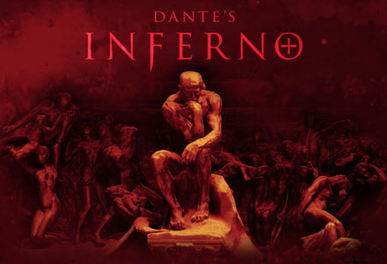

I am very excited to be reading and studying this book with you.
I hope you enjoy it as much as I do.

Tips for success during this unit:
- Do not Procrastinate!
- Hand things in early for feedback BEFORE the due date.
- Read ahead.
- Take notes and ask questions!
- Enjoy yourself

…Let’s Begin…

