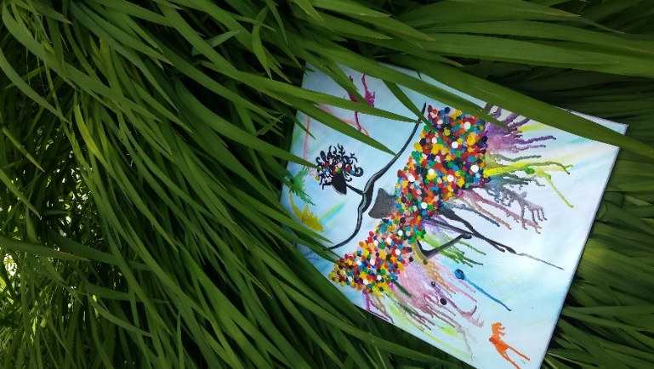
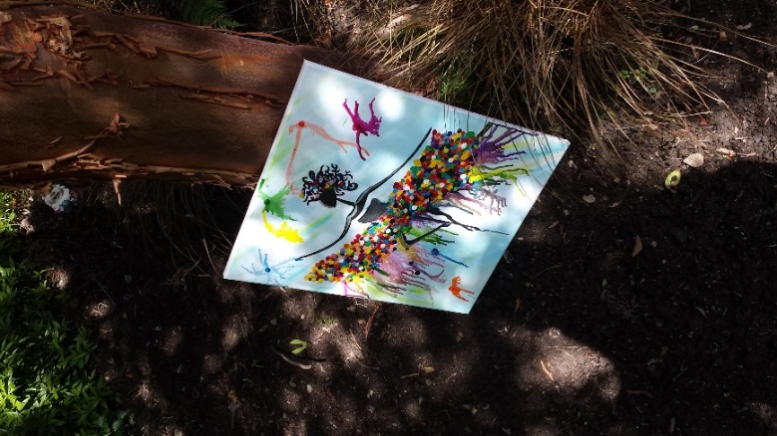
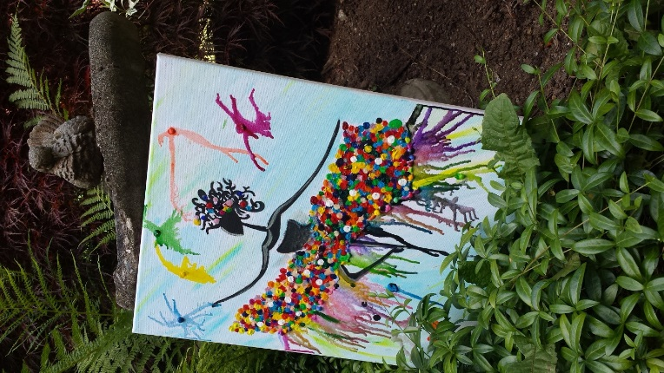
Dance Life

Life is a pair of ballerina point shoes. Brand new, the shoes are soft, elegant, and perfect. There are no holes, no scuff marks, no indication of pain or suffering.
The ballerina tries on her new shoes and feels for the first time, just how painful, hard, and uncomfortable they are. She knows that being on point will not be easy. She knows that she will have to work hard; overcome the blisters, bloody toes, and soar feet.
She does not give up.
As the ballerina practices, the shoe changes. The point is broken in, yet remains hard. The soles become bloody and worn. The shiny pink colour fades and starts to take on different hues and tones. Of course, the shoe itself remains beautiful. All of the work the ballerina has done to make the shoes as comfortable as they can be, has paid off. The ballerina performs her dream role in Swan Lake and the shoes make the perfect accessory.
As the production comes to a close, the shoes are so tattered and torn that they need to be replaced. Sadly, the shoes are thrown away.

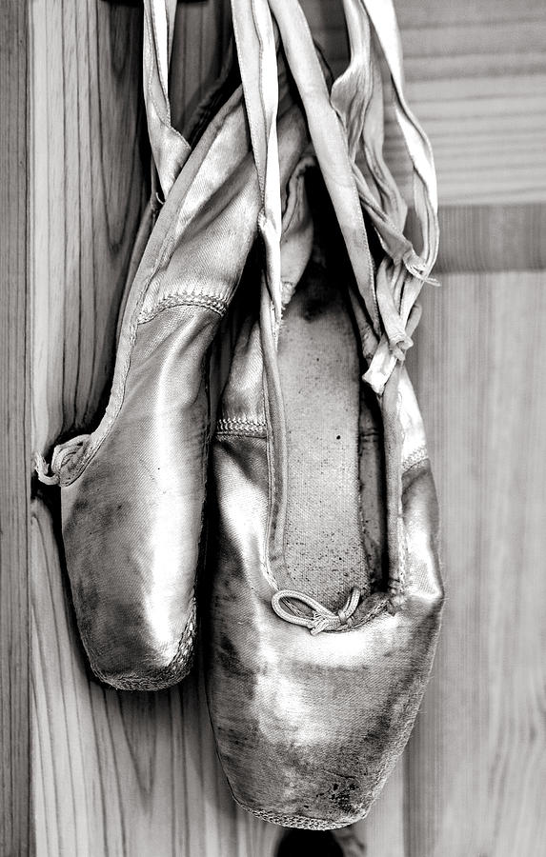
Dance Life

They are soft, elegant, perfect
No holes, scuffs, or blemishes
Mar their tender surface
No pain
No suffering
Yet.
On the surface, they are
They softest petals of an orchid,
But the ballerina tries on
Her new dancing shoes
She doubts they will comfort her.
She wonders if overcoming the blisters,
Bloody toes
Sore feet
Is worth the practice.
The pointe will not be easy,
But it never is.
The more she practices,
And the more dust, sweat
And blood
Become engrained into the soles
And her soul
The more she is sore.
She soars.

