30 April 2014 Last updated at 00:03 ET

LA Clippers owner race row ban welcomed
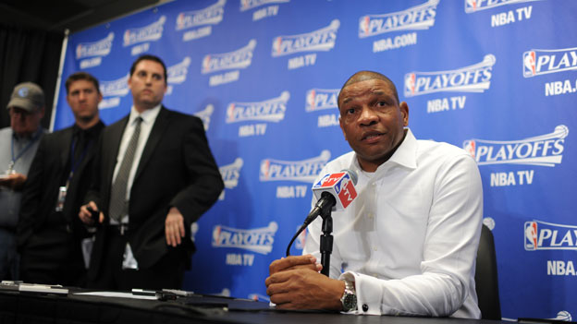Doc Rivers said the healing process could now begin
The ban imposed on the LA Clippers basketball team owner over racist remarks has received widespread praise.
Team coach Doc Rivers said the lifetime ban and fine for Donald Sterling was the "start of a healing process".
Several civil rights organisations and stars of the game, past and present, have applauded the National Basketball Association for taking swift action.
Mr Sterling was recorded asking a woman not to associate in public with black people or bring them to games.
His remarks have earned him a lifetime ban from the NBA, whose commissioner Adam Silver urged the Board of Governors - the other team owners - to force Mr Sterling into selling.

Praise for the ban
Mr Silver told reporters that Mr Sterling's "hateful opinions... simply have no place in the NBA".
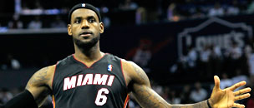
The league has also fined Mr Sterling $2.5m (£1.5m), the maximum allowed, in a package of measures that have been described as the harshest punishment in the history of the NBA.
Mr Rivers said: "I thought Adam Silver today was fantastic.
"He made a decision that really was the right one, that had to be made. I don't think this is something that we rejoice in or anything like that."
The players were happy that there was a resolution, he said, adding: "I think we're all in a better place because of this."
In a joint statement, the National Urban League, the National Action Network, the National Association for the Advancement of Colored People and the National Coalition on Black Civic Participation supported Mr Silver's announcement.
That decision, the statement said, was "a bold, courageous and resolute message".
Some sponsors had dumped the team as the race row deepened but following the ban, electronics company Samsung said it would resume advertising, starting with Tuesday evening's play-off game against the Golden State Warriors.
Former players also commended the swift action.
"I believe that today stands as one of those great moments where sports, once again, transcends, where sports provides a place for fundamental change on how our country should think and act," said Kevin Johnson, former NBA star and mayor of Sacramento, who has acted as an adviser to the NBA players' union.
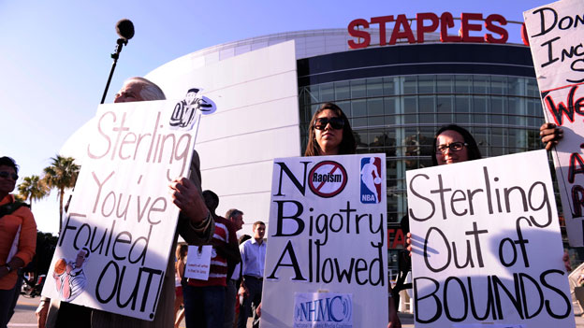
Below: Protests against Sterling were held ahead of Tuesday's game
But others said they believed the punishment was too harsh, given the fact it was a private conversation.
The ban means Mr Sterling will be unable to participate in all team business or attend any NBA practices or games.
Boxing superstar Floyd Mayweather has expressed an interest in buying the team, according to ESPN, as has another boxer, Oscar De La Hoya.
The row erupted on Friday when celebrity news website TMZ published a 10-minute audio recording in which Mr Sterling criticised a woman, believed to be his girlfriend, for posting photographs of herself with black friends at Clippers games.
"It bothers me a lot that you want to broadcast that you are associating with black people. Do you have to?" the man says.
The remarks caused an immediate uproar among basketball fans across the country, and drew condemnation from President Barack Obama.
The players staged a silent protest, going through a pre-match warm-up with shirts on inside-out to hide the team's logo.

